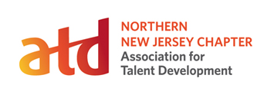

2016 Chapter Event Calendar

Month | Meeting Topic | Event | Location
January  20 | Taking the Guess Out of Assess | Chapter Meeting | Parsippany
February  10 | Conquering the Fears of Virtual Training | Professional Development | Parsippany  + Virtual
March  9 | 25 Icebreakers to Drive Audience Interaction | Chapter Meeting | Parsippany
April  7 | Mastering Storytelling for Maximum Impact | Joint Chapter Meeting | Bridgewater
April  19 | Best Practices Sharing | Special Interest Group | Roseland
June  13 | Recap from ICE | Chapter Meeting | Parsippany
June  15 | Executive Breakfast: Jeff Fernandez, Grovo | Executive Advisory Council | Murray Hill
July  19 | Best Practices Sharing | Special Interest Group | Roseland
August  24 | Annual Summer Social | Networking | Basking Ridge
September  20 | Sizzling Strategies to Gain Executive Support | Chapter Meeting | Wayne
October  14 | Using Live Streaming to Build Your Learning Community | Professional Development | Parsippany
November  17 | Executive Roundtable | Executive Advisory Council | Florham Park
December  5th – 9th | Employee Learning Week | Community Outreach | Virtual

